**CSE326 – HTML Project Work**

**Topic – Social Media Web Page**

**: Group Members :**

**1. Anshi Yadav – 12210421**

**2. Polepalli Pranay Deepak - 12215466**

**3. Dipankar Pradhan – 12215634**

**Section : K22UT**

**INTRODUCTION**

**Social Media is an internet based form of communication.**

**Social media platforms alows users to have conversation , share information and create web content. There are many forms of social media including blogs, social networking sites, photo sharing sites, and virtual worlds.**

**Sign In / Sign up page**





**Home Page of our website**

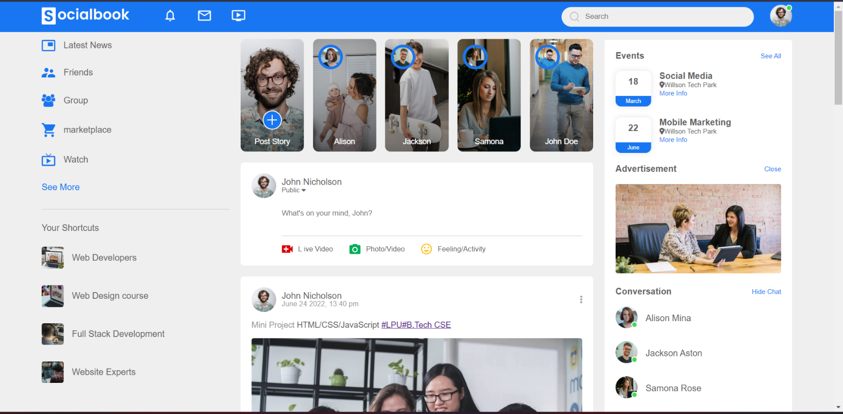

**Pofile Page of our website**

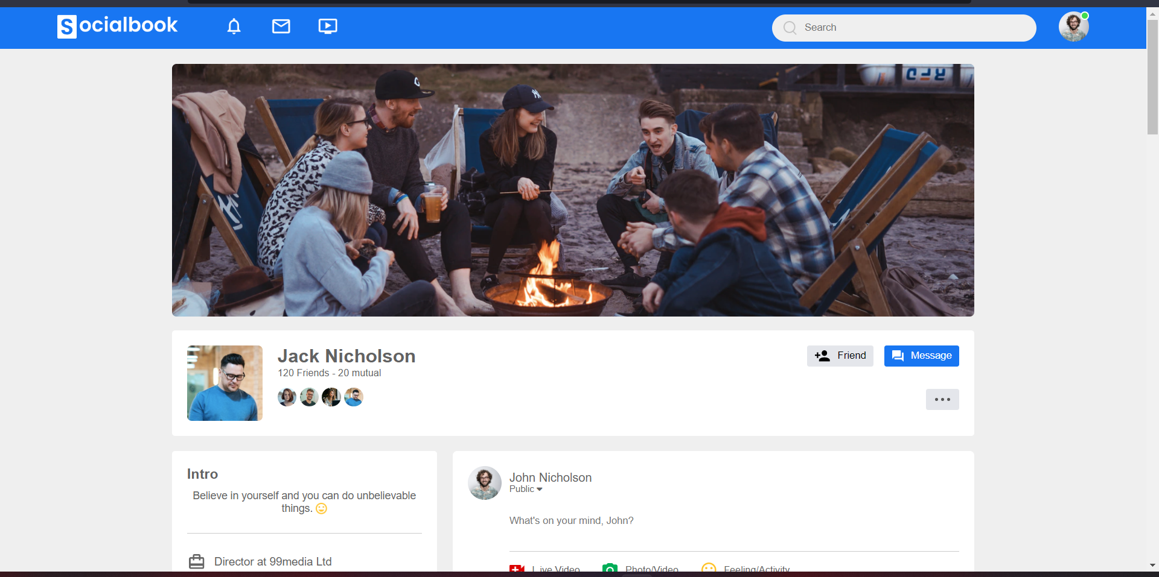

**We can switch to dark mode by clicking on the**

**“Toggle” button beside user profile**

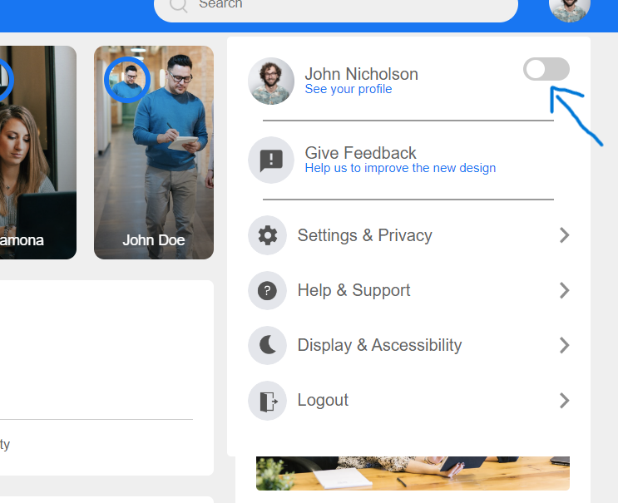

**Dark mode**

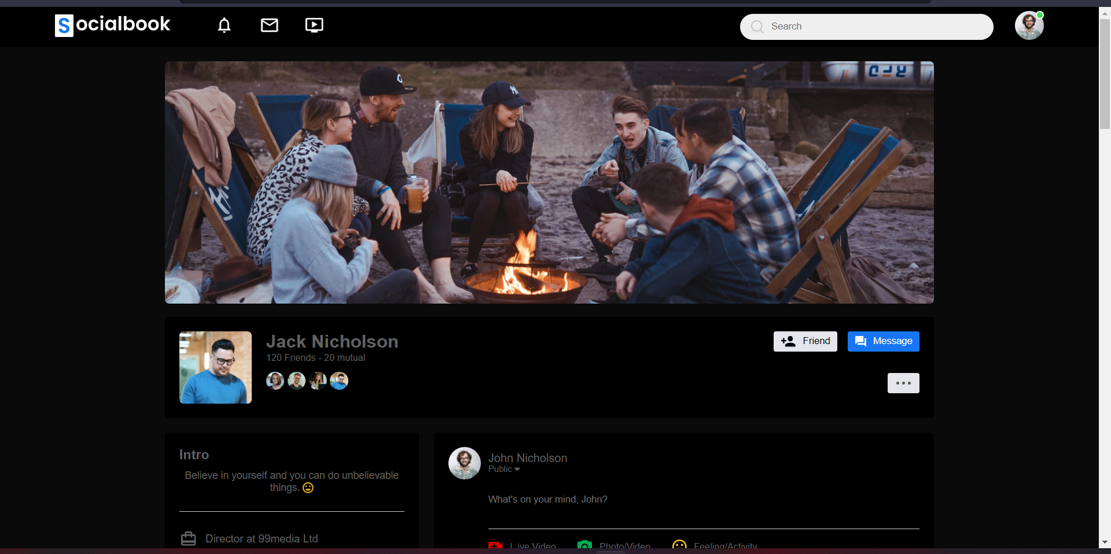

**We can switch to profile page by clicking on the “See your profile button”**

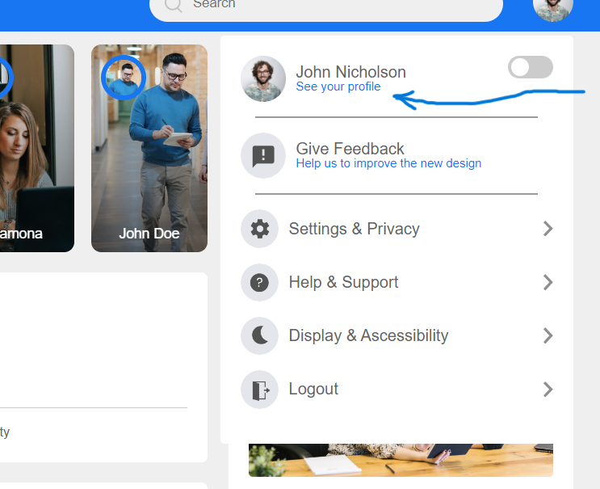

**What we have used :**

* **HTML**
* **CSS**
* **JavaScript**
* **Tags used in HTML:**
* **<div>**
* **<html>**
* **<head>**
* **<body>**
* **<title>**
* **<hr>**
* **<br>**
* **<img>**
* **<a>**
* **<nav>**
* **<p>**
* **<small>**
* **<i>**
* **<h4>**
* **<h3>**
* **<script>**
* **<meta>**
* **<link>**
* **<ul>**
* **<li>**

**CONCLUSION**

* **The project SocialBook is completed, satisfying the required design specifications. The website provides a user-friendly interface. It has been tested and everything work successfully. Thus, the website has fulfilled all the objectives.**
* **The UI is user-friendly and will reduce time consumption.**
* **The live results of the webpages has been shared. Hence, the software has proved to work efficiently.**

**REFERENCES**

* [**www.upgrad.com**](http://www.upgrad.com)
* [**www.google.com**](http://www.google.com)
* [**www.youtube/EasyTutorials**](http://www.youtube/EasyTutorials)
* [**www.geekforgeeks.com**](http://www.geekforgeeks.com)
* [**www.hackr.io**](http://www.hackr.io)
* [**www.slideshare.com**](http://www.slideshare.com)